**

*BRANCH WEBSITE:* [*http://branches.asce.org/wichita*](http://branches.asce.org/wichita)

*CALEB COLTRANE, PRESIDENT*

*Garver¨ 316-221-3022¨ crcoltrane@garverusa.com*

*MACEE CROWELL, VICE PRESIDENT*

*Kirkham Michael ◻ 316-303-3026◻ mcrowell@kirkham.com*

*DAKOTA McKEE, TREASURER*

*Gannett Fleming TranSystems ◻ 316-303-3051◻ dmmckee@transystems.com*

*ALLISON ATKINSON, SECRETARY*

*U.S. Geological Survey ◻ 317-682-7977◻ aatkinson@usgs.gov*

*SCOTT LINDEBAK, PAST PRESIDENT*

*Sedgwick County ◻ 316-660-1754◻ scott.lindebak@sedgwick.gov*



## **ASCE November Meeting Minutes**

Speakers: John Hunter – the Skidabrader Group

Topic: Pavement Texturing

Date: Wednesday, November 6, 2024

Location: Wichita Advanced Learning Library

711 W 2nd St N

Wichita, KS 67203

President Caleb Coltrane called the meeting to order at 12:00 pm and opened with announcements.

**Announcements**

* Hands on engineering will be happening each month and Kirkham Michael is volunteering on December 9th.

Vice-President Macee Crowell introduced the speaker: John Hunter, Director of Aviation Services, with Skidabrader Group, LLC out of Fort Worth, Texas. John is local to the Oklahoma City area.

**Presentation Notes**

John Hunter opened the presentation with brief introductions of his career and of the history of Skidabrader Group, LLC. John has worked in pavement and aviation for a couple decades, and while he leads the Aviation Division at Skidabrader, he is also familiar with Skidabrader’s road work. Skidabrader has been completing road and airport pavement texturing projects for over thirty years. They are a pavement texturing contractor; a key concept with pavement texturing is that it is a *process*, not a *product.*

Pavement texturing restores friction through sandblasting asphalt and concrete surfaces. Snowplowing and repeated use can cause a loss of friction on highway surfaces because the aggregates get worn down and become smooth. Similarly, airport pavements tend to lose friction in the touchdown and takeoff zones. For example, Skidabrader has worked with an airport that sees a high volume of heavy FedEx traffic and therefore experiences significant pavement wear. Skidabrader also works with DOTs to mitigate ghost striping on highway pavements. Pavement texturing can also be used for asphalt bleed remediation.

The pavement texturing process is completed with connected trucks; one truck has the sandblasting equipment and a shot recycler and the second truck has a dust collector. The dust collector truck is detachable and it takes about 4-5 minutes to switch trucks. The shot is collected with an electromagnet and then recycled. The dust is collected with a vacuum system and then stored for later disposal in accordance with the regulations of the jurisdiction. The process proceeds at a rate of about 60 feet per minute. The bi-directional shotblast head can be calibrated by changing the shot velocity, blast pattern, and shot volume to get the required roughness on the pavement. Four spinning wheels propel the steel shot into the pavement. Typically, each project will include a test strip. The shotblast head is 6 feet wide and can swivel 18 inches in either direction. Pavement texturing is often compared to diamond grinding; while diamond griding puts divots in aggregate which may eventually collapse, pavement texturing cleans around the pieces of aggregate. In this way, pavement texturing reduces the glare on new concrete and increases the macrotexture of asphalt pavements.

The pavement texturing surface treatment lasts 3-5 years, depending on the original aggregate in the pavement. For example, if the pavement aggregate is limestone, the treatment will last closer to 3 years. The improved pavement texture increases friction and better disperses water on the pavement. Oftentimes for airport runways, pavement texturing is done 30 feet on either side of the centerline. For roads and also for airport runways, friction testing is usually done before the project to figure out what areas would benefit most from pavement texturing.

Airport specifications for pavement texturing include P-101 150/5370-10H, P-101.33 150/5302-12C High Velocity Impact Removal. Sample road specifications include TxDOT Spec 3069.

Pavement texturing typically costs about $0.30-$0.40 per square foot but can be less for larger projects. Conditions must be dry to do pavement texturing, but there are no temperature restrictions. Projects are typically done at night because of lower traffic volumes; however, projects in urban areas will often be completed with day closures. Usually, two crews/trucks can run at the same time.

Link to Skidabrader Group, LLC: [Friction Texturing and Abrasion For Transportation And Airports | Skidabrader Group LLC](https://www.skidabrader.com/)

Link to case studies and reports on road safety retexturing applications: [Documentation | SKIDABRADER GROUP](https://www.skidabrader.com/documentation)

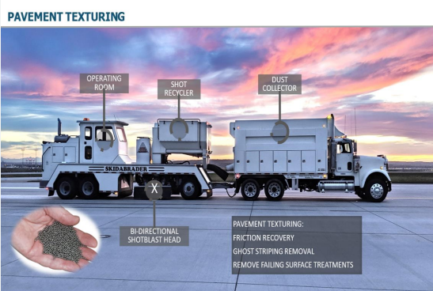

**Meeting Attendees**

|  |  |  |
| --- | --- | --- |
| 1 | Allison | Atkinson |
| 2 | David | Casebeer |
| 3 | Caleb | Coltrane |
| 4 | Macee | Crowell |
| 5 | Harlan | Foraker |
| 6 | Abdul | Hamada |
| 7 | Julianne | Kallman |
| 8 | Derek | Kratzer |
| 9 | Steve | Lackey |
| 10 | SCOTT | LINDEBAK |
| 11 | Dmitry | Lomachenko |
| 12 | Darryl | Lutz |
| 13 | Dakota | McKee |
| 14 | Daniel | Mealiff |
| 15 | Logan | Mills |
| 16 | John | Oldland |
| 17 | Lynn | Packer |
| 18 | Behrooz | Rahbar |
| 19 | Garrett | Reed |
| 20 | Tyler | Ummel |
| 21 | Luke | Vohs |
| 22 | Tyler | Voth |
| 23 | Daniel | Schrant |
| 24 | Chris | Leaver |
| 25 | Ky | Louanghaksaphone |

Meeting adjourned by President Caleb Coltrane at 1:00 p.m.

Minutes respectfully submitted by Secretary Allison Atkinson.